RBAC (Role-Based Access Control) in Spring Security

1. What is RBAC?
Role-Based Access Control (RBAC) is a security mechanism where:
Access to resources is controlled based on user roles, not individual users.
Instead of writing:
- “User A can access this API”
- “User B cannot”
We define:
- ADMIN → full access
- USER → limited access
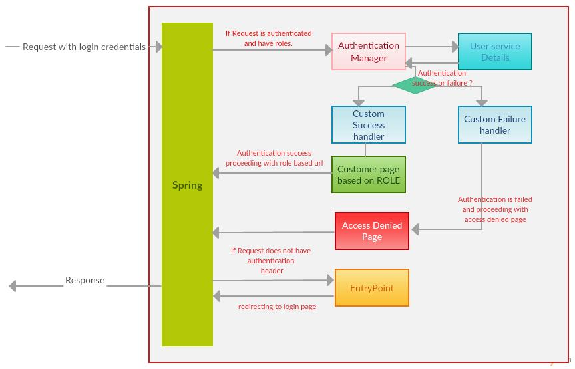
Example (Library Management System)
Role | Permissions
ADMIN | Add / Delete / Update Books
USER | View Books

2. Authentication vs Authorization
Concept | Meaning
Authentication | Who are you?
Authorization | What can you do?

Flow
- JWT → identifies user (Authentication)
- RBAC → decides access (Authorization)
- JWT validates identity
- Then roles decide access

3. Where RBAC fits in Spring Security
- JWT validates user
- SecurityContextHolder stores user
- RBAC checks role before method execution
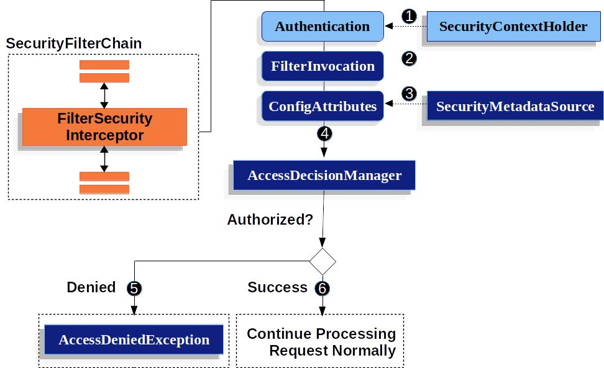

4. What is SecurityContext?
SecurityContext is:
A container that holds authentication details of the current request
Contains:
- Username
- Roles (authorities)
- Authentication status
This tells Spring:
“This user is authenticated with these roles”
SecurityContext Flow (Internal Working)
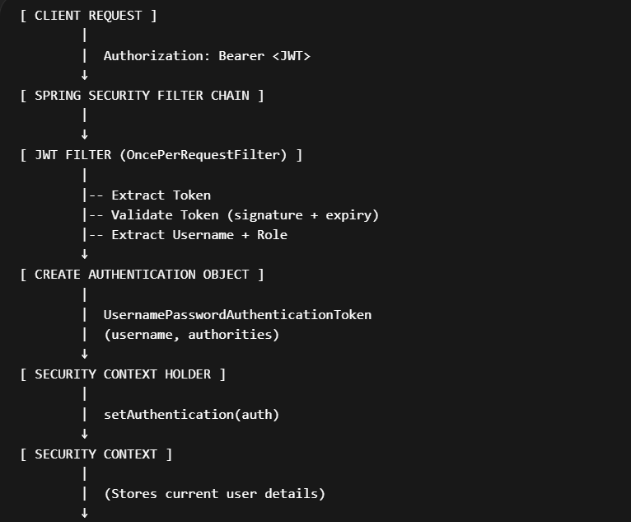
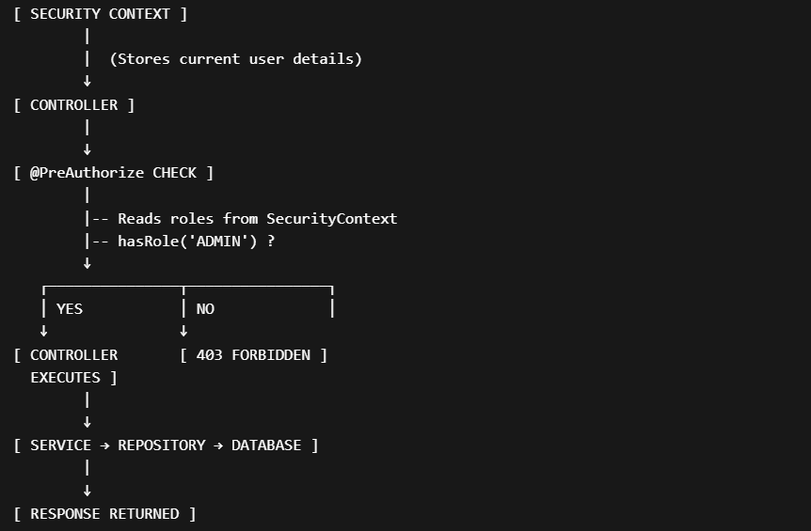
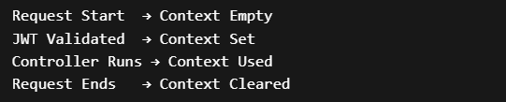
Without Security Context :
- Spring doesn’t know user identity
- RBAC cannot work
- @PreAuthorize will fail

5. @EnableMethodSecurity
Enables method-level security in Spring
✅ Without it
✅ With it
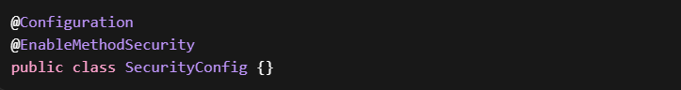Now Spring starts enforcing RBAC rules

6. @PreAuthorize (Core of RBAC)
Checks authorization BEFORE method execution
Example
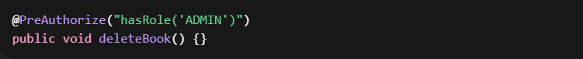
Internal Working
- Method call intercepted
- Spring reads annotation
- Fetch roles from SecurityContext
- Evaluate condition
- Allow / deny
Common Expressions
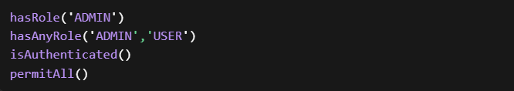

7. Complete RBAC Flow

Step-by-step Flow
- Client sends request with JWT
- JwtFilter extracts token
- Token validated
- Role extracted from JWT
- Convert role → ROLE_ADMIN
- Create Authentication object
- Store in SecurityContext
- Controller method called
- @PreAuthorize checks role
- Access granted / denied

JWT → Filter → SecurityContext → RBAC check
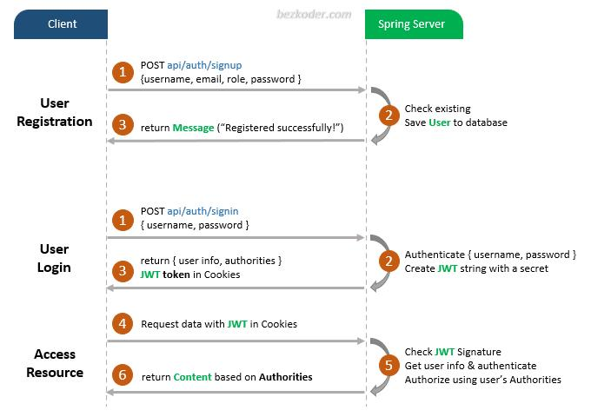
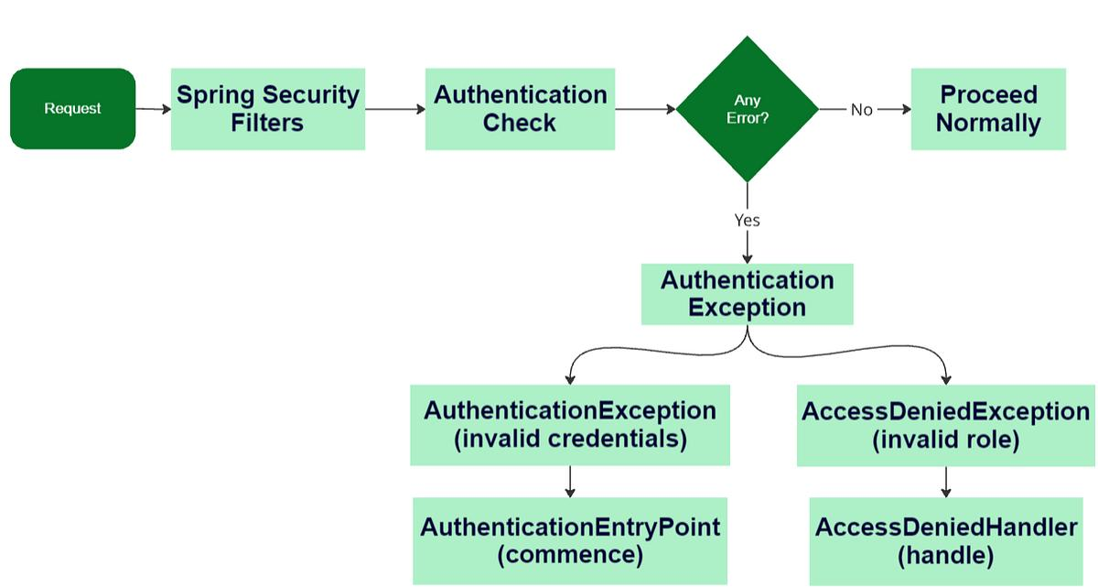
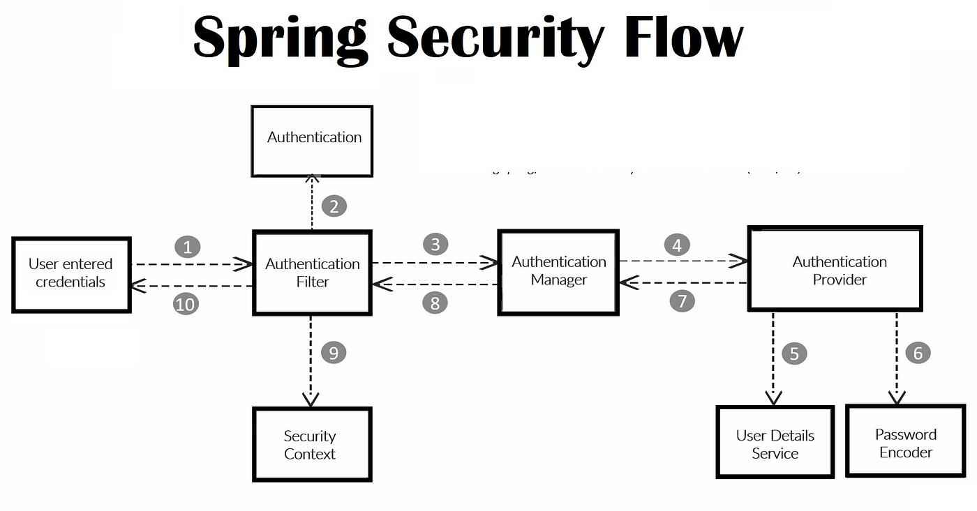
8. Implementation (LMS Project)
Step 1: Add Role in Entity
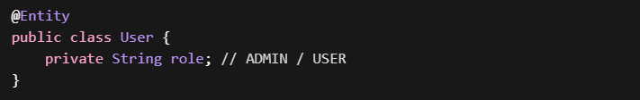
Step 2: Add Role in JWT
Step 3: Extract Role in JwtFilter
Step 4: Convert to Authority
Step 5: Set in SecurityContext
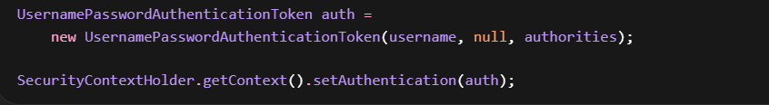

Step 6: Use RBAC
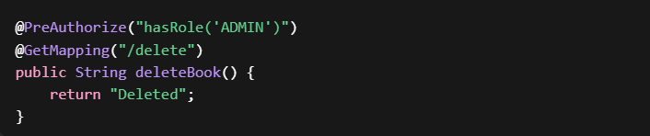

9. Debugging (Real Problems)
permitAll() vs authenticated()
Method | Meaning
permitAll() | No authentication required
authenticated() | Must be logged in

isAuthenticated()
Any logged-in user allowed
final vs non-final
Why final?
- Required for @RequiredArgsConstructor
- Constructor injection
- Better immutability
Common API Annotations
Annotation | Purpose
@PathVariable | URL value
@RequestParam | Query param
@RequestBody | JSON input

10. Annotation Cheat Sheet (RBAC Focus)
🔹 Core Security
- @EnableMethodSecurity → enables RBAC
- @PreAuthorize → access control
- SecurityFilterChain → config rules
- OncePerRequestFilter → JWT filter
🔹 Core Classes
- SecurityContextHolder → stores user
- UsernamePasswordAuthenticationToken → represents user
- PasswordEncoder → password hashing
11. Common Mistakes (Interview Traps)
- Forgetting @EnableMethodSecurity
- Not adding roles to JWT
- Not converting to ROLE_XXX
- Setting null authorities
- Expecting RBAC without SecurityContext

12. Interview Questions
1. What is RBAC?
Role-Based Access Control (RBAC) is a mechanism where access to resources is granted based on roles assigned to users, not individual identities.
Instead of defining permissions per user, roles like ADMIN or USER are defined, and permissions are attached to these roles.
This makes the system scalable, maintainable, and easier to manage in real-world applications.

2. Difference between Authentication and Authorization?
Authentication is the process of verifying who the user is (identity validation), typically done using credentials like username and password or JWT.
Authorization is the process of determining what the authenticated user is allowed to do, based on roles or permissions.
In simple terms:
Authentication = Identity
Authorization = Access control

3. What is @PreAuthorize?
@PreAuthorize is a method-level security annotation used to enforce authorization rules before a method executes.
It evaluates expressions like role checks or authentication status and decides whether the method should be allowed to run.
If the condition fails, Spring Security blocks execution and returns a 403 Forbidden response.

4. What is SecurityContext?
SecurityContext is a container used by Spring Security to store authentication details of the current request.
It holds information such as the logged-in user, roles, and authentication status.
This context is created per request and is cleared once the request is completed.

5. How does Spring Security know the current user?
Spring Security identifies the current user through the SecurityContextHolder, which stores an Authentication object.
This object is populated during request processing (for example, by a JWT filter), and it contains user details and roles.
All further authorization decisions rely on this stored information.

6. What is UsernamePasswordAuthenticationToken?
It is an implementation of the Authentication interface used by Spring Security to represent a successfully authenticated user.
It contains:
- Principal (user identity)
- Credentials (usually null after authentication)
- Authorities (roles/permissions)
This object is stored inside the SecurityContext and used across the request lifecycle.

7. How does JWT integrate with RBAC?
JWT handles authentication by carrying user identity and role information inside the token.
RBAC uses this role information to decide access permissions.
Flow:
- JWT provides identity + role
- Spring extracts role and stores it in SecurityContext
- RBAC checks role using annotations like @PreAuthorize

8. How are roles passed from JWT to Spring Security?
Roles are embedded as claims inside the JWT during token generation.
When a request is received, the JWT is validated and parsed, and the role is extracted.
This role is then converted into Spring Security authorities and stored in the SecurityContext, making it available for authorization checks.

9. What happens internally when @PreAuthorize is used?
When a method with @PreAuthorize is called, Spring Security intercepts the method using a proxy.
Before execution:
- It retrieves the Authentication object from SecurityContext
- Evaluates the authorization expression (e.g., role check)
- If the condition passes, method executes
- If it fails, access is denied with 403
10. Why roles must be prefixed with ROLE_?
Spring Security internally expects roles to follow a convention where they are prefixed with ROLE_.
When using methods like hasRole('ADMIN'), Spring automatically converts it to ROLE_ADMIN.
If roles are not stored with this prefix, authorization checks may fail.

11. Why always getting 403 even after login?
Common reasons:
- Roles not present in JWT
- Roles not correctly mapped to authorities
- Missing ROLE_ prefix
- SecurityContext not properly set
- @PreAuthorize condition not matching
- User authenticated but not authorized
403 means authentication succeeded, but authorization failed.

12. Difference between permitAll() and authenticated()?
permitAll() allows access to everyone, including unauthenticated users.
authenticated() restricts access only to users who are logged in (authenticated).
- permitAll → open endpoint
- authenticated → requires login
13. Why @PreAuthorize not working?
Common causes:
- @EnableMethodSecurity not enabled
- SecurityContext not populated correctly
- Roles missing or incorrectly formatted
- Annotation placed incorrectly (e.g., wrong layer)
- Method not proxied by Spring (e.g., private method or internal call)
If @PreAuthorize is not working, it usually means Spring is not able to evaluate roles properly or method security is not enabled.

JWT + RBAC – Spring Security (1-Page Revision)
Authentication
- Verifies user identity
- Done using password/JWT
- Output → user is valid or not
Authorization (RBAC)
- Determines what user can access
- Based on roles (ADMIN, USER)
- Enforced using annotations like @PreAuthorize

🔹 JWT (JSON Web Token)
- Stateless authentication mechanism
- Token carries user identity + roles
Structure
- Header → algorithm
- Payload → claims (username, role, exp)
- Signature → prevents tampering

Key Points
- No session stored on server
- Sent in every request
- Must be validated each time

🔹 End-to-End Flow
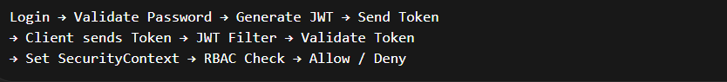
🔹 SecurityContext
Stores authentication details of current request
Contains
- User identity
- Roles (authorities)
- Authentication status
Lifecycle
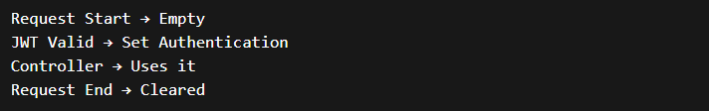

🔹 JWT → Spring Security → RBAC Flow
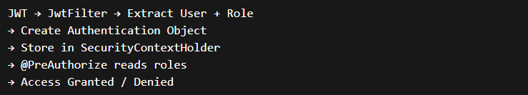

- SecurityContextHolder → stores current user
- Authentication → represents logged-in user
- UsernamePasswordAuthenticationToken → implementation of Authentication
- OncePerRequestFilter → JWT filter
- SecurityFilterChain → security rules

RBAC (Role-Based Access Control)
- Control access based on roles
Example
- ADMIN → full access
- USER → limited access
Enforcement
- @PreAuthorize("hasRole('ADMIN')")

🔹 Important Annotations
- @EnableMethodSecurity → enables RBAC
- @PreAuthorize → authorization check
- @RestController → API layer
- @RequestBody → input mapping
- @PathVariable → URL values
- @RequestParam → query params

🔹 Common Expressions
- hasRole('ADMIN')
- hasAnyRole('ADMIN','USER')
- isAuthenticated()
- permitAll()

🔹 Common Mistakes
- Missing @EnableMethodSecurity
- Roles not added in JWT
- Not converting to ROLE_XXX
- Not setting SecurityContext
- Using encode instead of matches
- Forgetting to send Bearer token

🔹 401 vs 403
Code | Meaning
401 | Not authenticated (invalid/missing token)
403 | Authenticated but not authorized

🔹 Debug Checklist
If API fails:
- Is JWT present in header?
- Is token valid (not expired)?
- Is role present in token?
- Is role mapped correctly (ROLE_)?
- Is SecurityContext set?
- Is @PreAuthorize condition correct?

🔹 permitAll vs authenticated
- permitAll → no login required
- authenticated → login required

Spring Security uses SecurityContextHolder to store Authentication per request, and RBAC is enforced using annotations like @PreAuthorize based on roles extracted from JWT.

